Volleyball Practice (DATE)_________________________________

Equipment Practice Objectives:

Concentrate on TACTICS and TECHNIQUE; Not Emotion
******************************************************************************************
Pre-Practice Warm-up Drills
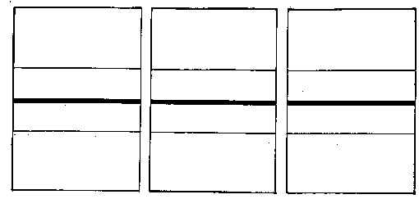
Passing Technique:
1. Perfect Pass 2. Step-around 3. Shuffle RT/LF
4. Dig and Tip-Get 5. Over the Shoulder (RT/LF)

Wall Blocking:
1. Solo Block
2. Seal w/both hands (RT/LF)

Stretching/Team Goal

4-corners
Blocking Footwork
Outside-In, Inside-Out, Travelers
Mblocker Technique

Team Defense Footwork
1. Front/Back
2. Team Reaction

Hitting:
Tennis Ball Approaches w/transition
Shadow Approaches
MH: 2-5-out; Lblk-3, Rblk-2
LOH: 5-3-2 ROH: Out-In-2

Line Serving (Chase)
1 to 5; 1 to 1; 5 to 5; Short Serve

Basic Technique Drills:
Passing: Pairs, Line, Shuttle, Butterfly
System drills:
Base-Read-Chase-Control-Cover
1. Tornado-Serve, Serve Reception
2. Transition Offense-Free Ball, From Block
3. Spike Coverage Offense
4. Out of System Offense

5. 3-Runs
1.Serve Receive
2. Freeball
3. Defense vs. LOH/MH/ROH
3. Defense vs. Downball

6. 1. Serve Reception 2. Coach versus Defense
Right vs.Left, Left vs. Right
Middle vs. Middle

